**Experiment 2.3**

**Student Name: Yana Srivastava UID: 20BCS2279**

**Branch: BE CSE Section/Group: 906 / B**

**Semester: 5th Date of performance: 29.09.22**

**Subject: Problem Based Learning in Java Subject Code: 20CSP_321**

1. **Aim/Overview of the Practical:**

Operations on String List.

1. **Task to be done / Which logistics used:**

Write a program to perform the basic operations like insert, delete, display, search in list. List contains String object items where these operations are to be performed.

1. **Steps for experiment/practical/Code:**

import java.util.*;

public class stringList

{

public static void main(String[] args)

{

LinkedList<String> list= new LinkedList<>();

Scanner sc= new Scanner(System.in);

int choice;

do {

System.out.println("1. Insert");

System.out.println("2. Search");

System.out.println("3. Delete");

System.out.println("4. Display");

System.out.println("5. Exit");

System.out.println("Enter your choice: ");

choice= sc.nextInt();

switch (choice) {

case 1:

System.out.println("Enter Item to be inserted:");

String item = sc.next();

System.out.println();

list.add(item);

System.out.println("Item inserted successfully");

break;

case 2:

System.out.println("Enter Item to search:");

item = sc.next();

System.out.println();

if (list.contains(item))

{

System.out.println("Item found in the list!!");

}

else

{

System.out.println("Item not found in the list!!");

}

break;

case 3:

System.out.println("Enter Item to be deleted:");

item = sc.next();

System.out.println();

if(list.contains(item))

{

list.remove(item);

System.out.println("Item removed successfully!!");

}

else

{

System.out.println("Item do not exist!");

}

break;

case 4:

Iterator itr = list.iterator();

System.out.println("Items of list are:");

while (itr.hasNext())

{

System.out.println(itr.next());

}

break;

}

}

while (choice!=5);

}

}

1. **Result/Output/Writing Summary:**

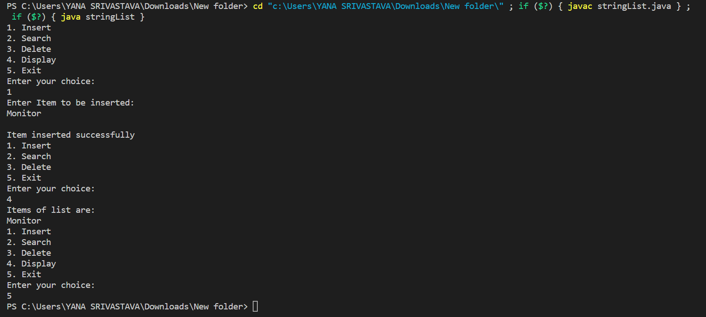

**Learning outcomes (What I have learnt):**

* 1. Learnt about maps.
  2. Got an overview of the maps and hashing.
  3. Get to know about crucial test cases.
  4. Got an understanding about referencing of maps.
  5. Learn how to insert, search, delete an element in a list.

**Evaluation Grid (To be created as per the SOP and Assessment guidelines by the faculty):**

|  |  |  |  |
| --- | --- | --- | --- |
| Sr. No. | Parameters | Marks Obtained | Maximum Marks |
| 1. |  |  |  |
| 2. |  |  |  |
| 3. |  |  |  |
|  |  |  |  |